Day 3: The Visitors

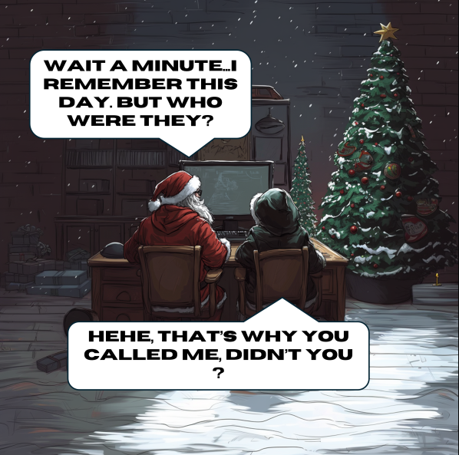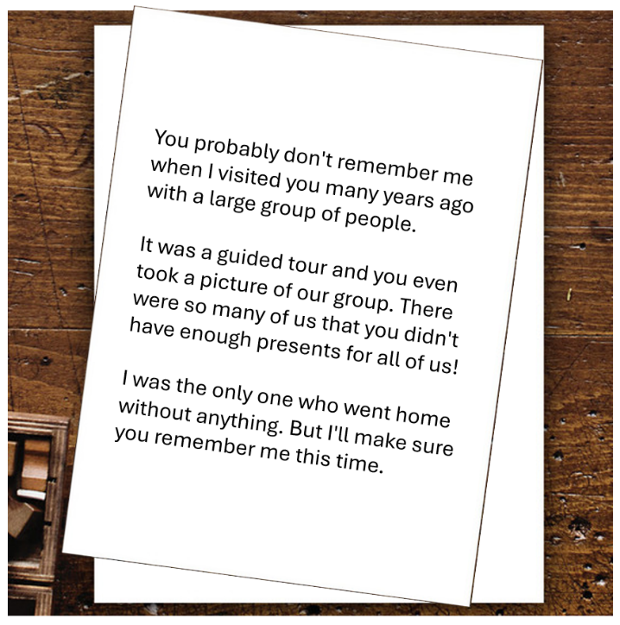

*Q: What is the name of the group?*

My first instinct is to start with the Santa Claus Office in Rovaniemi, where you can meet Santa Claus. There might be a photo attached to this place in Google Maps which shows a large group. I scrolled through a whole bunch of images and realized it was futile because of the large number of photos. I did notice a number of photos of a photo wall, with one of these framed photos in particular showing a large group. I figured that this might be the photo that is referenced in this challenge. So, I did a Google Reverse Image search for one of the pictures of this photo wall, in order to find more close-up ones of this particular framed photo. Eventually, I indeed found a photo that showed this photo in more detail. I noticed a logo on the bottom-left, in which two clowns are portrayed, and the text seems to say something like “Sirchus Finlandir”. I Googled this text, which got corrected to “Sirkus Finlandia”. The logo seems to match the one in the picture. Therefore, I took a guess that the answer to this challenge is:

**Sirkus Finlandia**.